

Practices for Secure Software Report

Table of Contents
Document Revision History 3
Client 3
Instructions 3
Developer 4
1. Algorithm Cipher 4
2. Certificate Generation 4
3. Deploy Cipher 4
4. Secure Communications 4
5. Secondary Testing 4
6. Functional Testing 4
7. Summary 4
8. Industry Standard Best Practices 4

Document Revision History

Version | Date | Author | Comments
1.0 | 10/16/2026 | Jordan Epperson

Client



Instructions

Submit this completed practices for secure software report. Replace the bracketed text with the relevant information. You must document your process for writing secure communications and refactoring code that complies with software security testing protocols.

- Respond to the steps outlined below and include your findings.
- Respond using your own words. You may also choose to include images or supporting materials. If you include them, make certain to insert them in all the relevant locations in the document.
- Refer to the Project Two Guidelines and Rubric for more detailed instructions about each section of the template.

Developer
Jordan Epperson

Algorithm Cipher

I recommend SHA-256 as the checksum algorithm and TLS over HTTPS for protecting data in transit. SHA-256 is part of the SHA-2 family and produces a 256-bit (32-byte) digest. It is a one-way cryptographic hash, not encryption: the digest is used to detect changes, while HTTPS/TLS encrypts communications. The application uses Java's MessageDigest API to calculate the SHA-256 digest of a UTF-8 encoded demonstration string and formats the result as hexadecimal. A receiver can calculate the digest again and compare values to detect accidental or malicious changes; a checksum alone does not prove who sent the data, so authenticated HTTPS and, where needed, a keyed MAC or digital signature are important additional controls.
Modern secure communication combines symmetric and asymmetric cryptography. During a TLS handshake, asymmetric cryptography and certificates support authentication and key establishment; negotiated symmetric session keys then efficiently encrypt application traffic. Secure random values are used by modern TLS implementations to help establish unpredictable session secrets. Keys and random values must come from trusted cryptographic providers, not hand-built random-number logic. Older algorithms such as DES and export-grade ciphers are obsolete, and MD5 and SHA-1 are unsuitable for collision-resistant security uses. AES and modern TLS configurations are widely used today. RSA remains useful for certificates and certain key operations, but should use appropriate key sizes and modern protocol settings. This project uses a 2048-bit RSA self-signed certificate for a classroom HTTPS demonstration and SHA-256 for the checksum. A self-signed certificate is not automatically trusted by browsers and is not a substitute for a certificate issued and managed by a trusted authority in production.

Certificate Generation
Insert a screenshot below of the CER file.

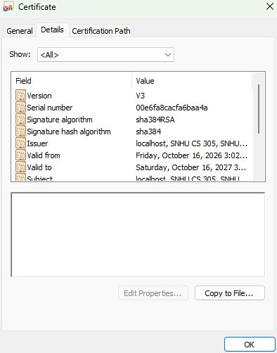

Deploy Cipher
Insert a screenshot below of the checksum verification.

Secure Communications
Insert a screenshot below of the web browser that shows a secure webpage.

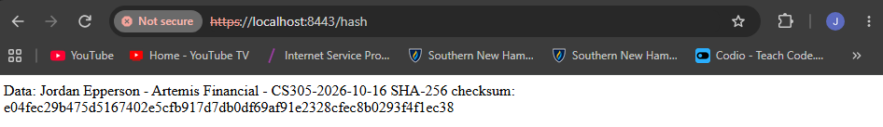

Secondary Testing
Insert screenshots below of the refactored code executed without errors and the dependency-check report.

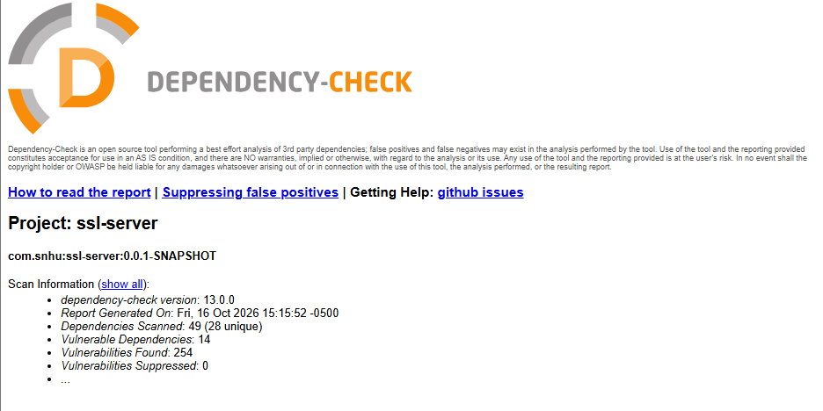

Functional Testing
Insert a screenshot below of the refactored code executed without errors.

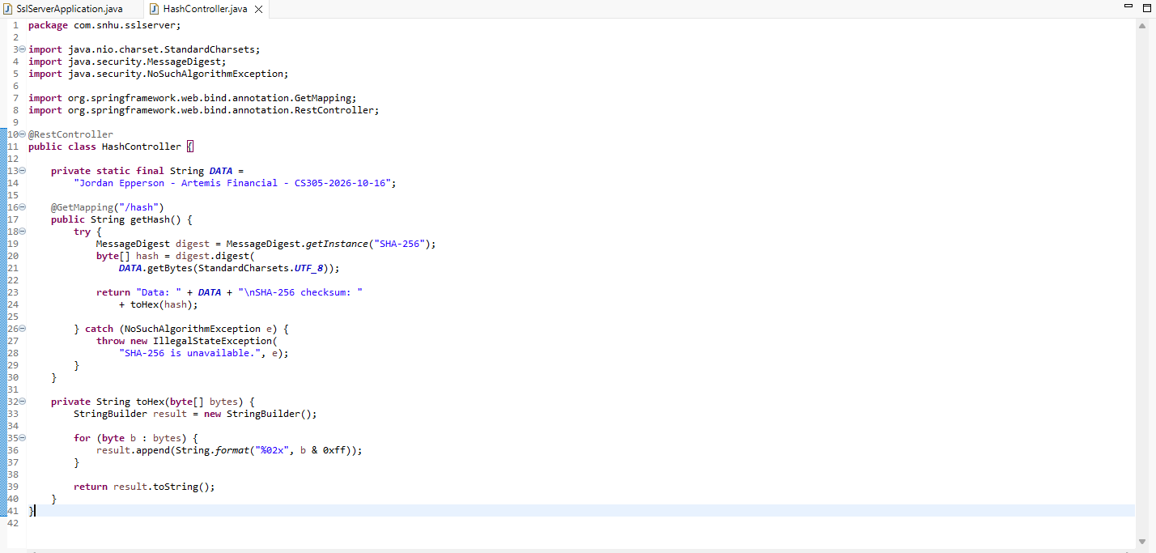

Summary

The application was refactored to add a REST endpoint at /hash and to enable HTTPS on port 8443. The endpoint calculates a SHA-256 digest for a unique demonstration string and returns both the original data and its hexadecimal digest. The application uses Java's standard cryptography API rather than a custom hash implementation. The server configuration now specifies a PKCS12 keystore, alias, and password, and a self-signed RSA certificate was generated with Java Keytool and exported as a CER file.
The changes address several stages in the vulnerability assessment process: identifying security requirements, implementing safeguards, and testing the updated application. SHA-256 supports data-integrity checking; HTTPS/TLS protects confidentiality and integrity while data travels between browser and server; and a certificate supports server identity checking, although this self-signed certificate requires explicit trust for a browser to accept it without a warning. I would then run functional tests, review the code for unsafe patterns, and run OWASP Dependency-Check to identify known vulnerable third-party components. Test and scan results should be recorded and any findings triaged and fixed before release. The included code and certificate are prepared for local demonstration, but successful execution and scan status must be confirmed in the user's Eclipse environment and documented with actual screenshots.

Industry Standard Best Practices

I applied secure-coding practices by using the standard Java MessageDigest implementation, selecting SHA-256 instead of obsolete hash algorithms, encoding the input consistently as UTF-8, and converting the digest to hexadecimal in a dedicated helper method. The endpoint returns a controlled response and does not expose a stack trace to the client if the required algorithm is unavailable. HTTPS is configured so the browser communicates with the server over TLS instead of plain HTTP. The certificate uses a 2048-bit RSA key and is exported separately for inspection. The code keeps checksum generation separate from application startup, making it easier to test and maintain.
Security is layered rather than dependent on one feature. A hash can reveal changed data, but it does not encrypt the data or authenticate its source. TLS protects the connection, while certificate validation helps the client verify the server. Dependency scanning can reveal known vulnerable libraries, and manual code review plus functional tests can catch logic and configuration errors that a dependency scanner cannot. For production, the keystore password should be supplied through a protected secret/configuration mechanism rather than committed in source control; a trusted CA-issued certificate, supported Java/Spring versions, current TLS settings, access controls, logging, and regular dependency updates should also be used. These practices reduce the chance of data exposure, tampering, service disruption, and costly incident response, helping preserve client trust and the company's reputation.

